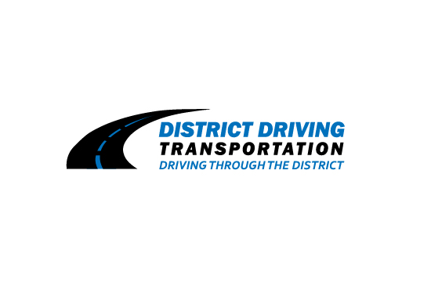

VENDOR APPLICATION FORM

PLEASE REACH OUT TO OUR POINT OF CONTACT TO CHECK THE STATUS OF AVALIBLE SEATS. CALL 240-229-5669 or EMAIL US AT DISTRICTDRIVING@GMAIL.COM OUR MISSION IS TO PROVIDE SAFE ENVIROMENT FOR OUR CHILDREN AND COMMUNITY. IF YOU HAVE ANY QUESTIONS PLEASE GIVE US A CALL. PLEASE GO ON WEBSITE TO REGISTER FOR SCHOOL.

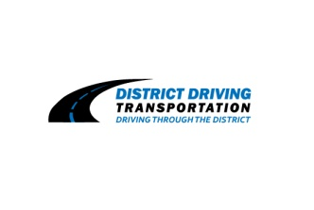

District Transportation Driving LLC - 2021/2022
“Driving through the District”
Van Registration
Website to register: www.districtdrivingllc.com
Student Name: ________________________
Student Name: ________________________
Parent Name: _________________________
Employer Name: ____________________________
Pick-Up/Drop Off Address: __________________________________________________________________________________________
Neighborhood/Subdivision: ______________________
Grade: ______
Cell Phone: _______________________
Home Phone: _____________________
Pick-Up Drop Off Address (If Multiple):
____________________________________________________________________________________

Special Pick-Up/Drop Off Instructions:
____________________________________________________________________________________
Bi-Weekly: _________ Monthly: _________ Yearly: _________

In order for our company to plan the most time efficient routes, please indicate interest in our service in advance to your start date. All payment plans will begin the 1 month prior to actual start month. Following the first payment, all other payments much be made through District Driving Transportation LLC in the form of cash, credit card payment, or PayPal. All Payments apart from cash, there will be an additional charge of 4%. Monthly Payments are due no later than the 5th of each month. (Late charge of $25.00 will be charged if payment is received after the 5th of the month)

Services

The cost our services are the following:

- $190.00 for one Service PM or AM
- $350.00 for both Services AM and PM

Full Service (AM/PM) ______ AM Only ________ PM Only ____ Yearly: _________

Terms and Conditions

I understand upon acceptance into the Van transportation, I am financially committing to transportation through District Driving Transportation for one full academic year. Refunds will be considered through written appeal to the company. Transportation is provided on a first come first serve basis through the authority of District Driving Transportation. This submitted form does not guarantee acceptance into our transportation service. Preschool students are permitted to ride the van, only when parents provide safety seats. District Driving may cancel service commitments 15 days in advance in writing due to payment failure or disobedience circumstances while riding transportation. * There is a strict 10 minute “wait” policy in affect during AM or PM routes, due to the company’s scheduling system. By signing is committing to one full academic year even during breaks and holidays. Parents must also provide a 24- hour notice if the child is not riding the van. A $25.00 charge can be applied if the company comes to your residence in an effort to provide service. There are additional fees for after school activities if we deviate from our normal school scheduled route. All students are expected to be prompt when riding the route due to consideration for the school schedule as well as other students riding the shared route.

Parent/Guardian Signature ____________________________ Date _____________

