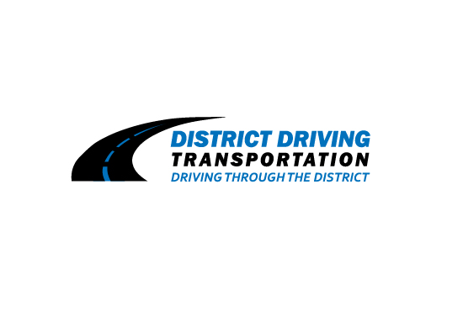

VENDOR APPLICATION FORM

PLEASE REACH OUT TO OUR POINT OF CONTACT TO CHECK THE STATUS OF AVALIBLE SEATS. CALL 240-229-5669 or EMAIL US AT DISTRICTDRIVING@GMAIL.COM OUR MISSION IS TO PROVIDE SAFE ENVIROMENT FOR OUR CHILDREN AND COMMUNITY. IF YOU HAVE ANY QUESTIONS PLEASE GIVE US A CALL. PLEASE GO ON WEBSITE TO REGISTER FOR SCHOOL.

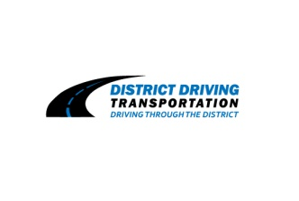

District Transportation Driving LLC - 2019/2020
“Prompt Quality Service in a God Friendly Environment”
Van Registration
Website to register: www.districtdriving.com
Student Name: ________________________
Student Name: ________________________
Parent Name: _________________________
Pick-Up/Drop Off Address: __________________________________________________________________________________________
Neighborhood/Subdivision: ______________________
Grade: ______
Cell Phone: _______________________
Home Phone: _____________________
Pick-Up Drop Off Address (If Multiple):
____________________________________________________________________________________

Special Pick-Up/Drop Off Instructions:
____________________________________________________________________________________
Weekly: ________Bi-Weekly: _________Monthly: _________

In order for our company to plan the most time efficient routes, please indicate interest in our service in advance to your start date. All payment plans will begin the 1 month prior to actual start month. Following the first payment, all other payments much be made through District Driving Transportation LLC in the form of cash, credit card payment, or PayPal. All Payments apart from cash, there will be an additional charge of 3%. Monthly Payments are due no later than the 5th of each month. (Late charge of $20.00 will be charged if payment is received after the 5th of the month)

Services
The cost our services are the following:

- $180.00 for one Service PM or AM
- $340.00 for one Service PM & AM

Full Service (AM/PM) ______ AM Only ________ PM Only ____ Yearly: _________

Terms and Conditions
I understand upon acceptance into the Van transportation, I am financially committing to van transportation through the District Driving Transportation for one full academic year. Refunds will be considered through written appeal to our company. Transportation is providing on a first come first served basis and the authority of District Driving Transportation. This form being submitted does not guarantee acceptance into our transportation program. Preschool students are permitted to ride the van, but parents must provide safety seats. District Driving may cancel commitment for van transportation within 15d ays advised of the route and times for all my students(s). I must cancel in writing. *No afterschool activities and can’t wait for child over 10 minutes in AM or PM, because throws off company’s schedule. Signing is committing to one full academic year even during breaks and holidays. Must provide 24- hour notice if child is not riding the van or $20.00 charge if we show up at your house. Additional charge for after school activities if we deviate from our normal school schedule.

Parent/Guardian Signature ____________________________ Date _____________

